 | Care plan, Care tracker, and medical diary  A patient workflow for Medil AI

The workflow in one line: Plan the treatment → receive reminders → record what happened → review the diary.

This guide explains how to add medications and care events, configure their schedule and reminders, confirm or mark events not performed, and understand how those records appear in the medical diary.
Medical safety: Medil AI records and organizes the plan you enter. Confirm medication, dose, test, appointment, and schedule decisions with a doctor, pharmacist, or other qualified health professional.

What is available
- Medication search, My medications, medication schedules, reminders, and medication tracking remain available without Medil AI+.
- Care events and the displayed medical diary and charts require Medil AI+ and are included during the free trial.
- Calendar computer display is available with Medil AI+ or an eligible free trial.
- Barcode and prescription scanning are available only in supported countries. Always compare AI-assisted transcription with the original prescription.

1. Build your medication plan

Find and verify the medication
- Open Medication search and search by commercial name or active ingredient.
- Open the medication and verify its active ingredients, strength, dosage form, and route.
- If the family contains several products or strengths, use the selectors at the top of the details page.
- Choose Add a prescription. Add medication in My medications and Care plan opens the same search.
Country safety: A saved prescription remains linked to its country database. If it cannot be resolved after a country change, Medil offers free-text conversion instead of opening a product from another country.

Enter the prescription instructions
- Prescribed amount: the quantity expected for each occurrence, such as 1 tablet or 1 injection.
- Regular dosing: start date, optional end date or number of days, frequency or interval, weekdays, and one or more times.
- As needed: use only when the prescription has no fixed repeating schedule.
- One-time dose: when neither regular dosing nor as needed is selected, choose one date and one time.
- Remark and cropped prescription: keep patient-specific instructions or the relevant cropped image when useful.
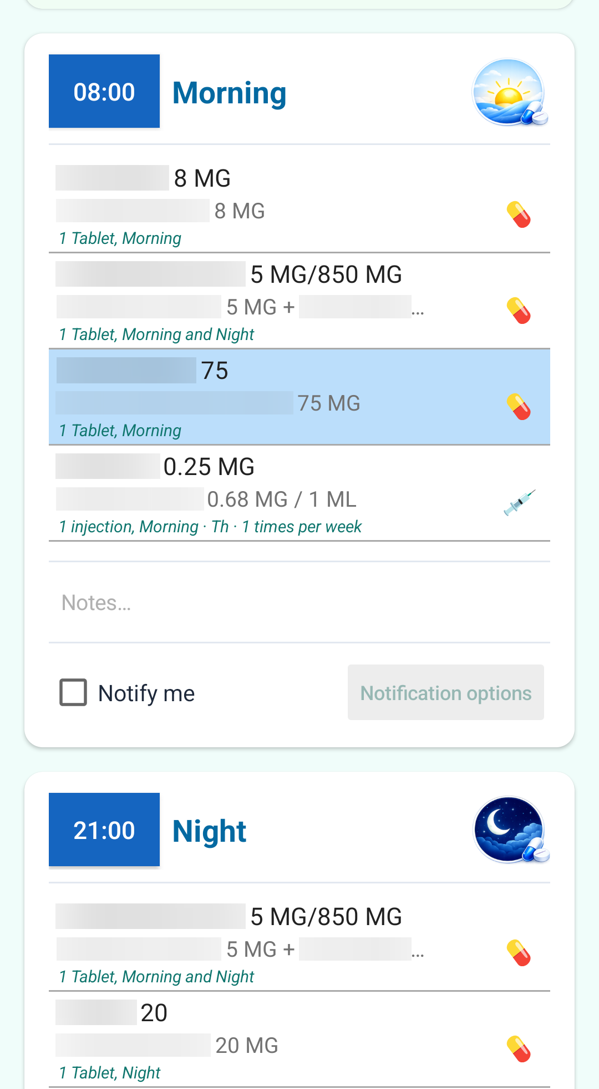
A redacted medication plan with oral and injection schedules.

Review or change a saved prescription
Open My medications or Care plan and tap the medication. Editable prescriptions offer Edit and Delete; deletion asks for confirmation and removes future occurrences and notifications.
A prescription opened from Care tracker is read-only so recording a dose cannot accidentally change the plan. Edit it from My medications or Care plan.

2. Add care events
Care events are optional Medil AI+ items for appointments and care-related tasks such as physiotherapy, a blood test, imaging, or a dressing change.

Repeating care event
- Choose Add care item and enter the event name and optional details.
- Select Regular dosing and choose the start date. Add an end date or number of days only when the series is limited.
- Choose Frequency for occurrences per day, week, or month, or Period for every specified number of hours, days, weeks, or months.
- Select all applicable weekdays and times, then save.
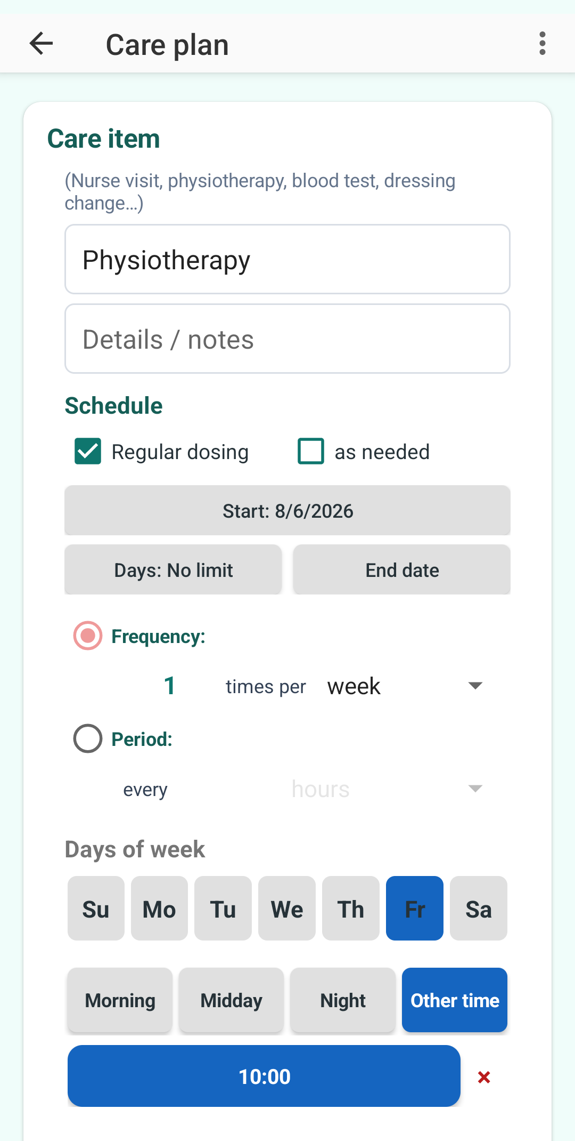 | 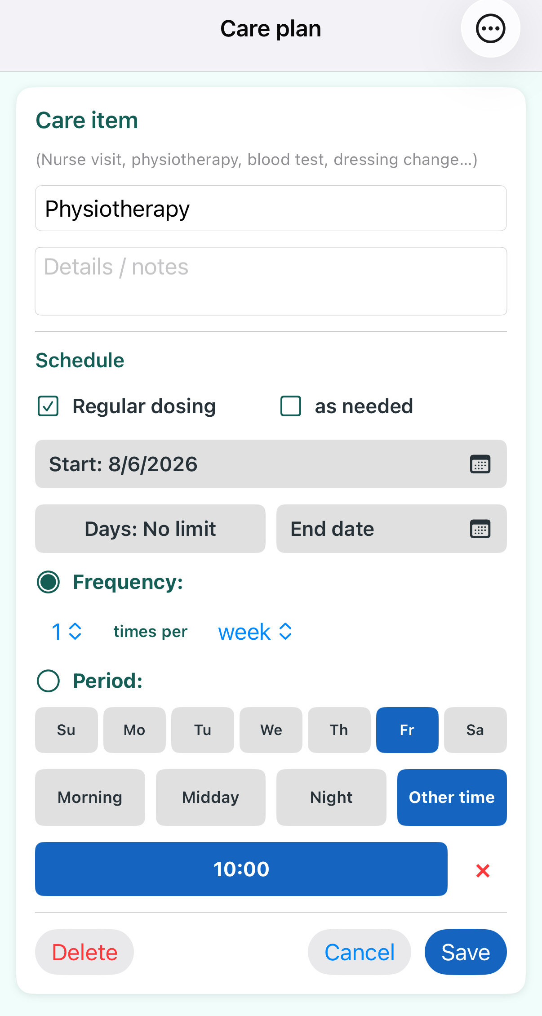
The same weekly physiotherapy plan on Android and iPhone.

One-time care event
Leave Regular dosing off, then choose one date and one time. The time button can be tapped again to change it.
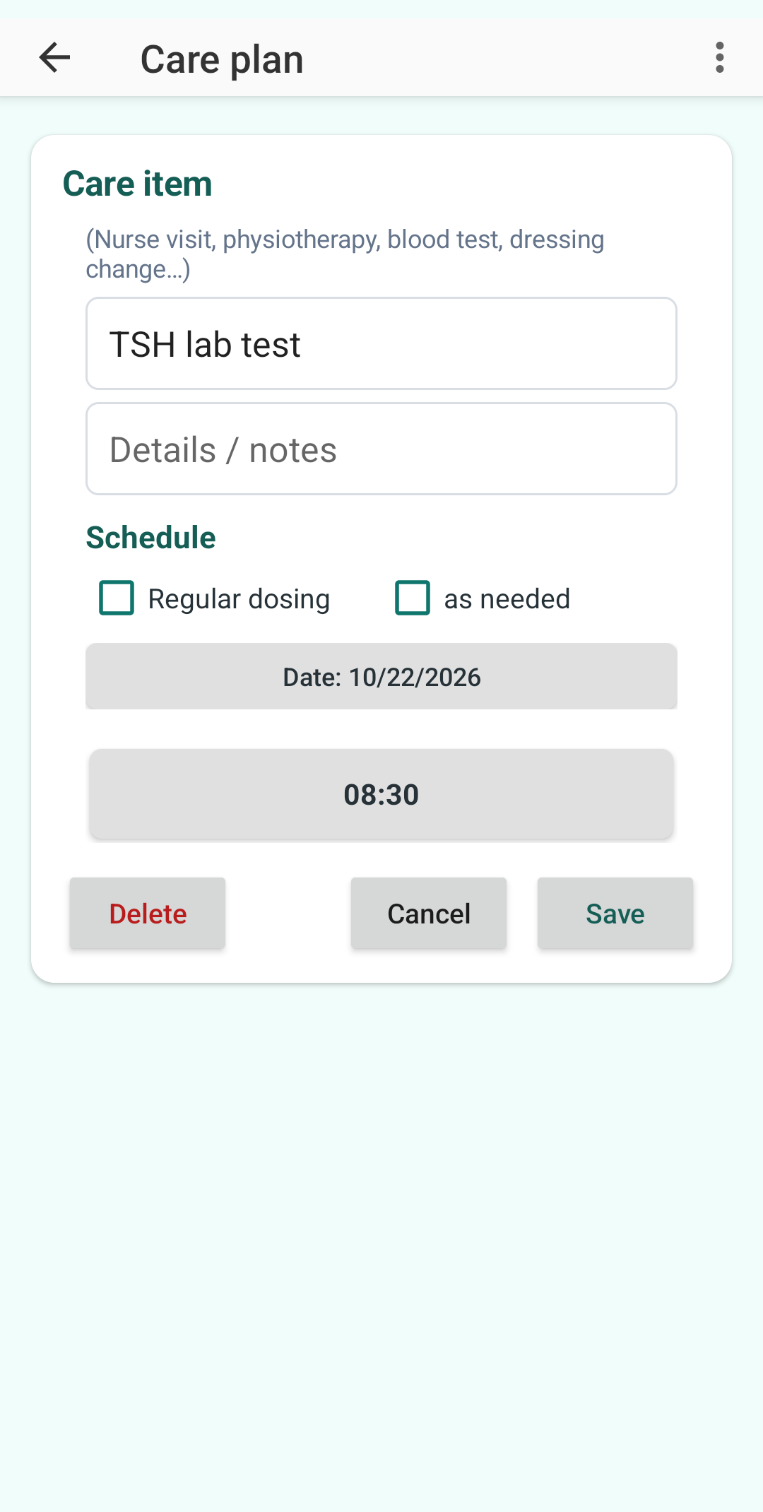 | 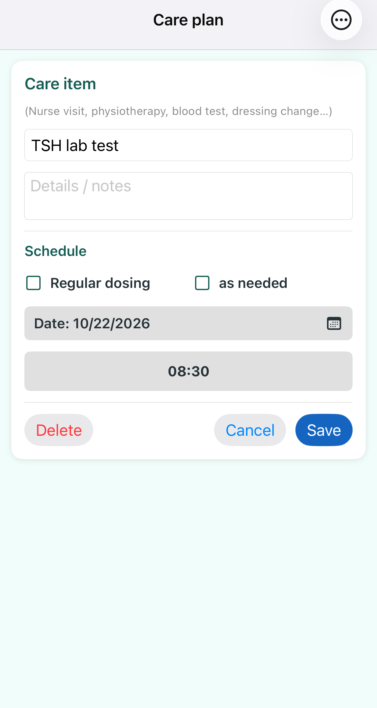
A one-time TSH blood test scheduled eight weeks ahead.
Tap a saved care item in Care plan to edit it with the same controls. Deletion requires confirmation and removes future occurrences and notifications.

3. Configure notifications

Default options
Care plan keeps default notification options for newly enabled time slots. The default is the Medil tone with three event-time reminders at 20-minute intervals.
- Sound choices: no sound, Medil tone, voice message, an existing sound file, or a personal recording.
- Android also offers a Medil vibration pattern. iPhone vibration is controlled by iOS rather than a separate Medil option.
- Before event: add one or more reminders in minutes, hours, or days before a care event.
- At event time: choose the number of repeated reminders and their interval.

Enable one time slot
- Turn on Notify me in the relevant Morning, Midday, Night, or custom-time section.
- Medil copies the current defaults to that time slot and confirms the copy.
- Open Notification options for the time slot if it needs different settings.
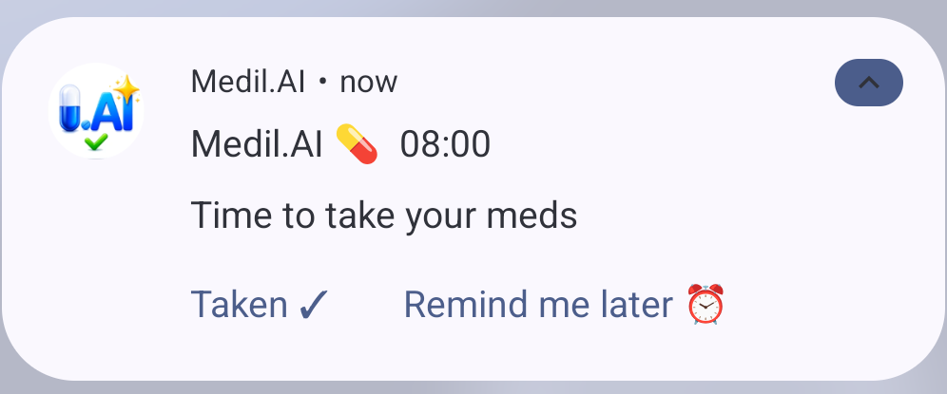
A medication reminder. Tapping it opens Care tracker for the occurrence.
System settings matter: Delivery depends on notification permission, volume, battery settings, Focus, and Do Not Disturb. Medil respects Focus and Do Not Disturb.

4. Record what happened in Care tracker
Open Care tracker from the home screen or tap a reminder. Use the date arrows to review the intended day.

Medication doses
- Each row shows the prescribed product and strength, route icon, prescribed amount, and personal instructions.
- The quantity control records the amount actually taken; it is separate from the prescribed amount.
- Confirm one medication with its check control, or confirm a whole time slot with Record all medications taken.
- After recording, use the red cancel control to reverse the record. Past dates require confirmation.
- The completion time is stored per medication only when recorded on the same date as the dose.

Care events
- Use the check to mark Complete and the red X to mark Not performed.
- Tap the active status control to return the event to incomplete.
- Add a remark when it helps explain what happened.
- Changing a past or future occurrence requires confirmation and suppresses reminders only for that occurrence.
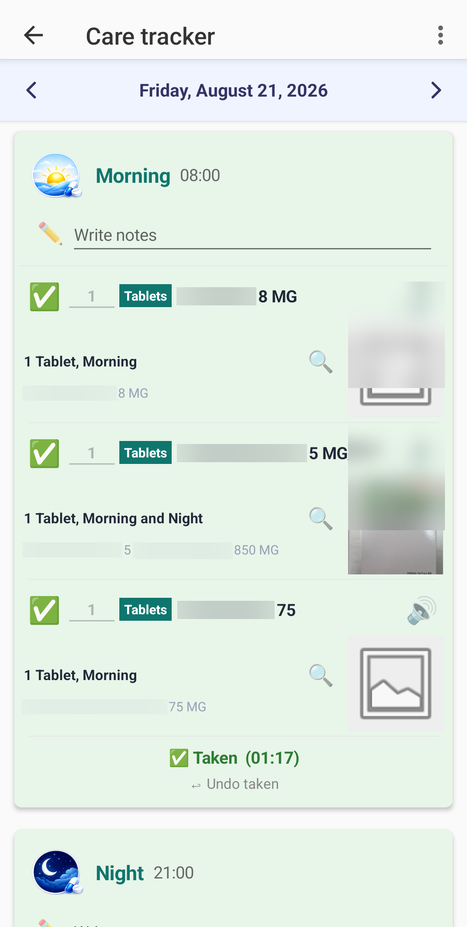
Redacted Care tracker evidence showing prescribed amounts and per-occurrence status.
Read-only review: Tapping medication content from Care tracker opens its prescription read-only. The speaker reads instructions aloud. Edit the prescription from My medications or Care plan.

5. Review the medical diary
The medical diary combines medication status, care events, and health measurements. It is generated from the same plan used by Care tracker.

Understand the symbols
- Pill: oral medication. Syringe: injection. Patch: other routes when no more specific oral or injection icon applies.
- Today and future dates show how many medications are scheduled.
- Past dates show a green check when all were taken, a red X when none were taken, or a taken/expected fraction when some were taken.
- Care events show a stethoscope, their time when upcoming, and a green check or red X after completion or non-performance.
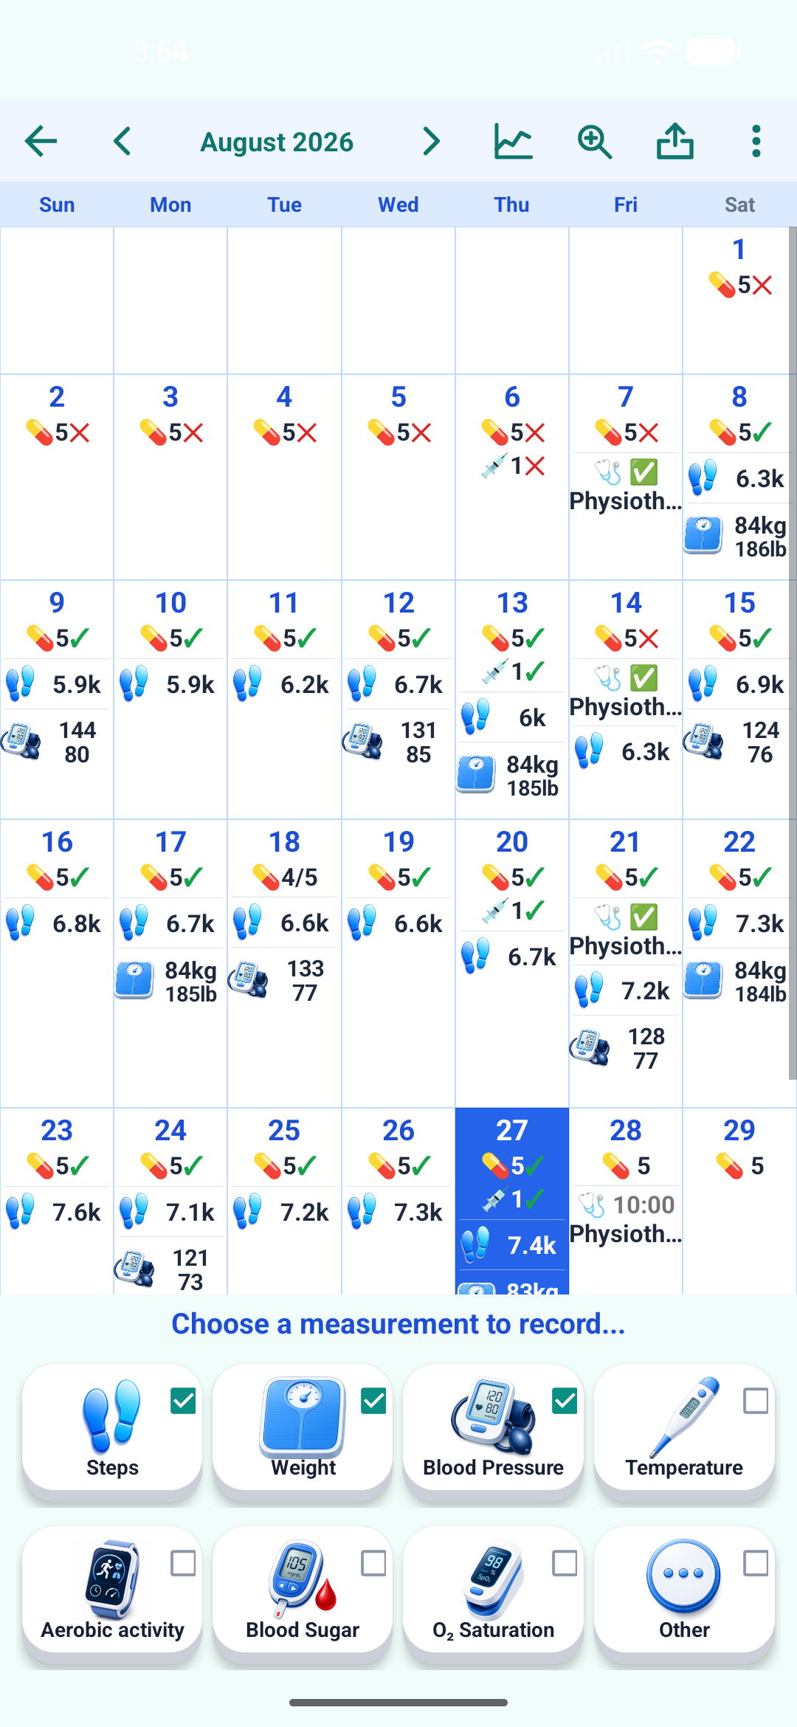 | 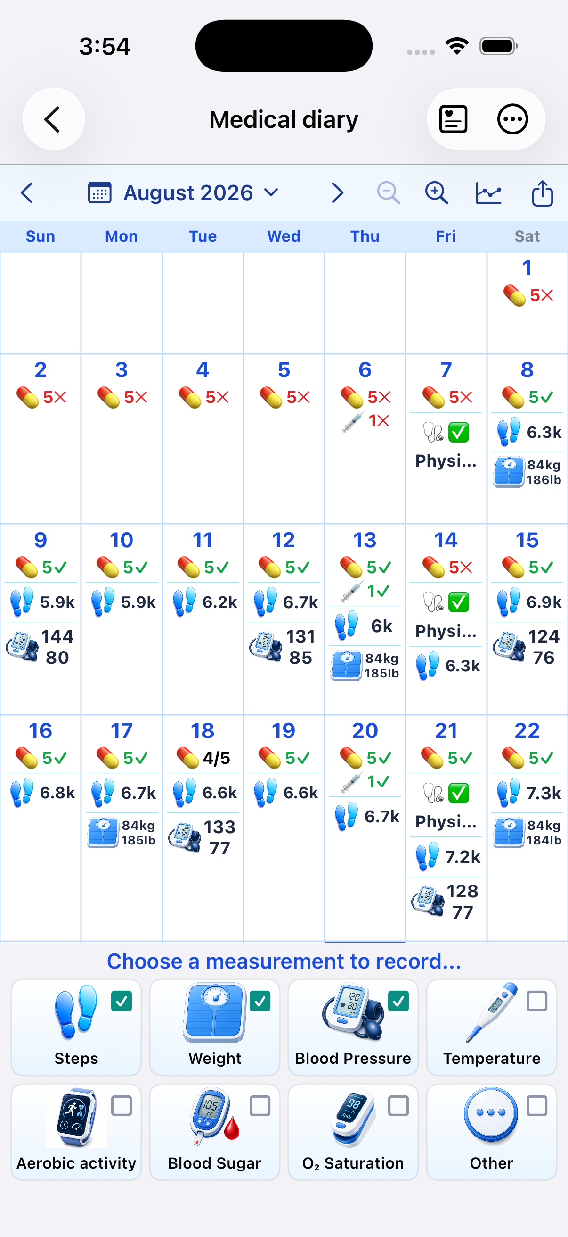
The August diary on Android and iPhone, using the same medication and care status model.
Tap a medication or care event in the diary to open Care tracker for that date. A selected calendar row expands when needed without changing the width of the seven day columns.

6. Filter, chart, export, and print
- Use the small toggles beside measurement icons to show or hide categories in the calendar. Medication records remain visible.
- Switch to chart view to compare selected measurements with medication tracking. Medication boxes align with their dates.
- In chart view, the chart button becomes a calendar button so one control switches between the two views.
- Calendar PDF export includes the whole selected month, medication and care records, status symbols, measurements, a title, and a legend. Chart PDF export also includes a title and legend.
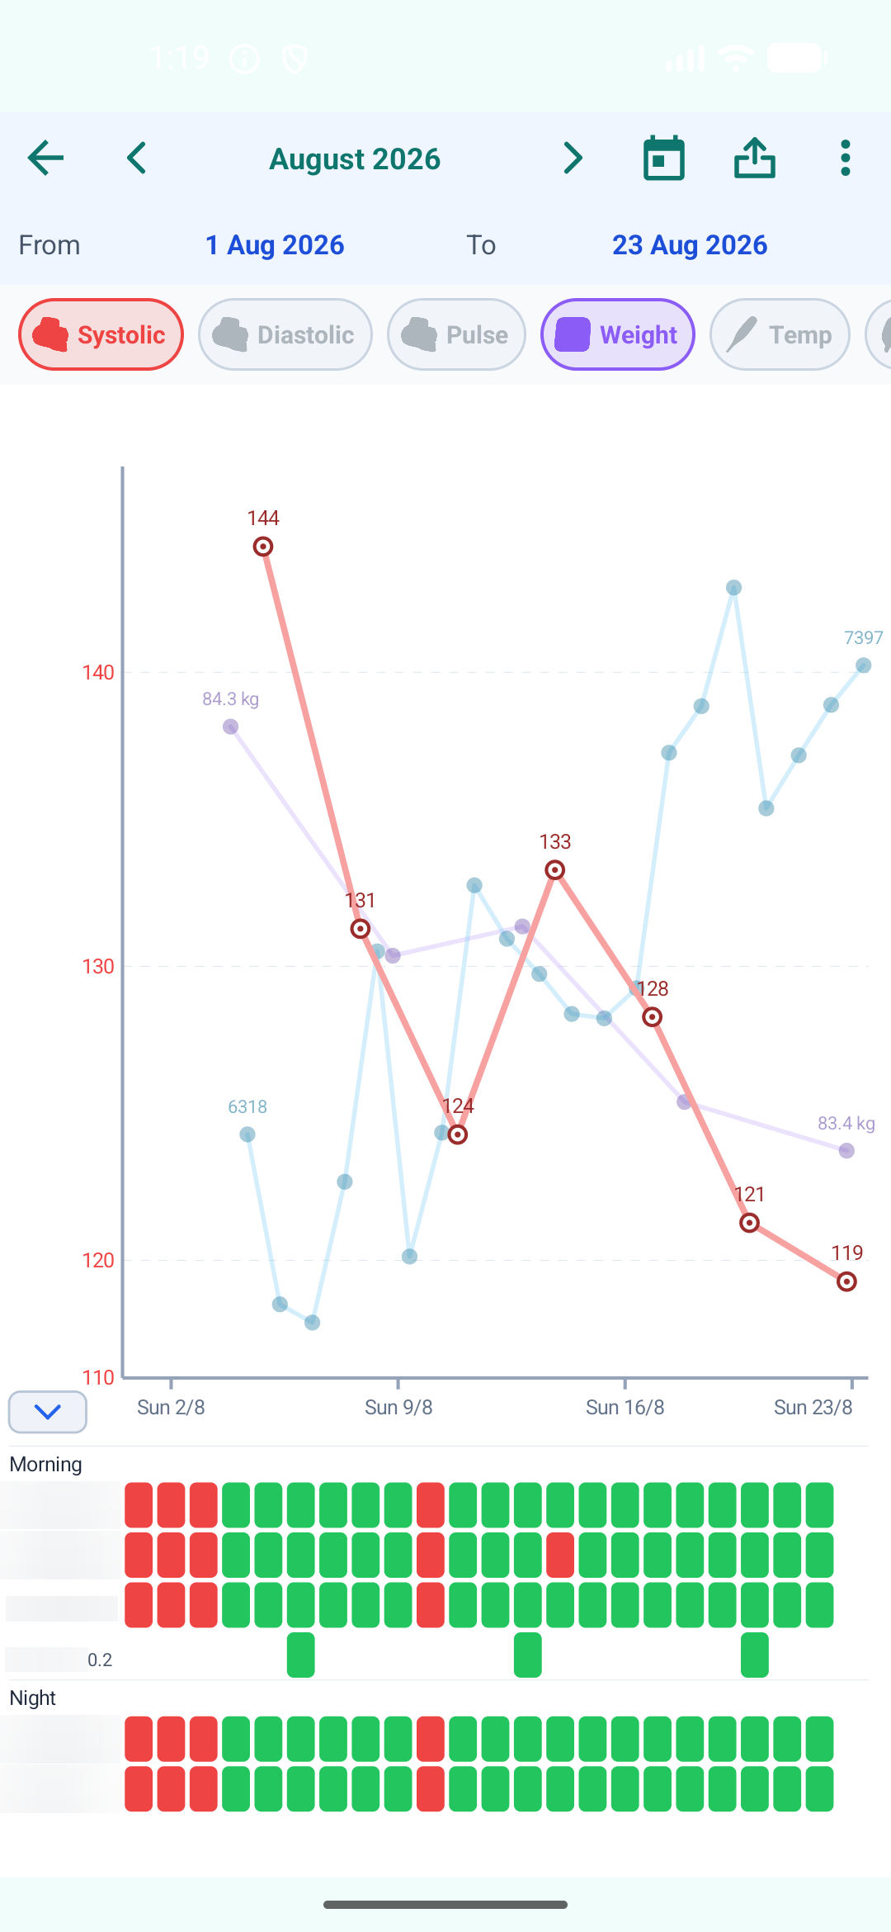 | 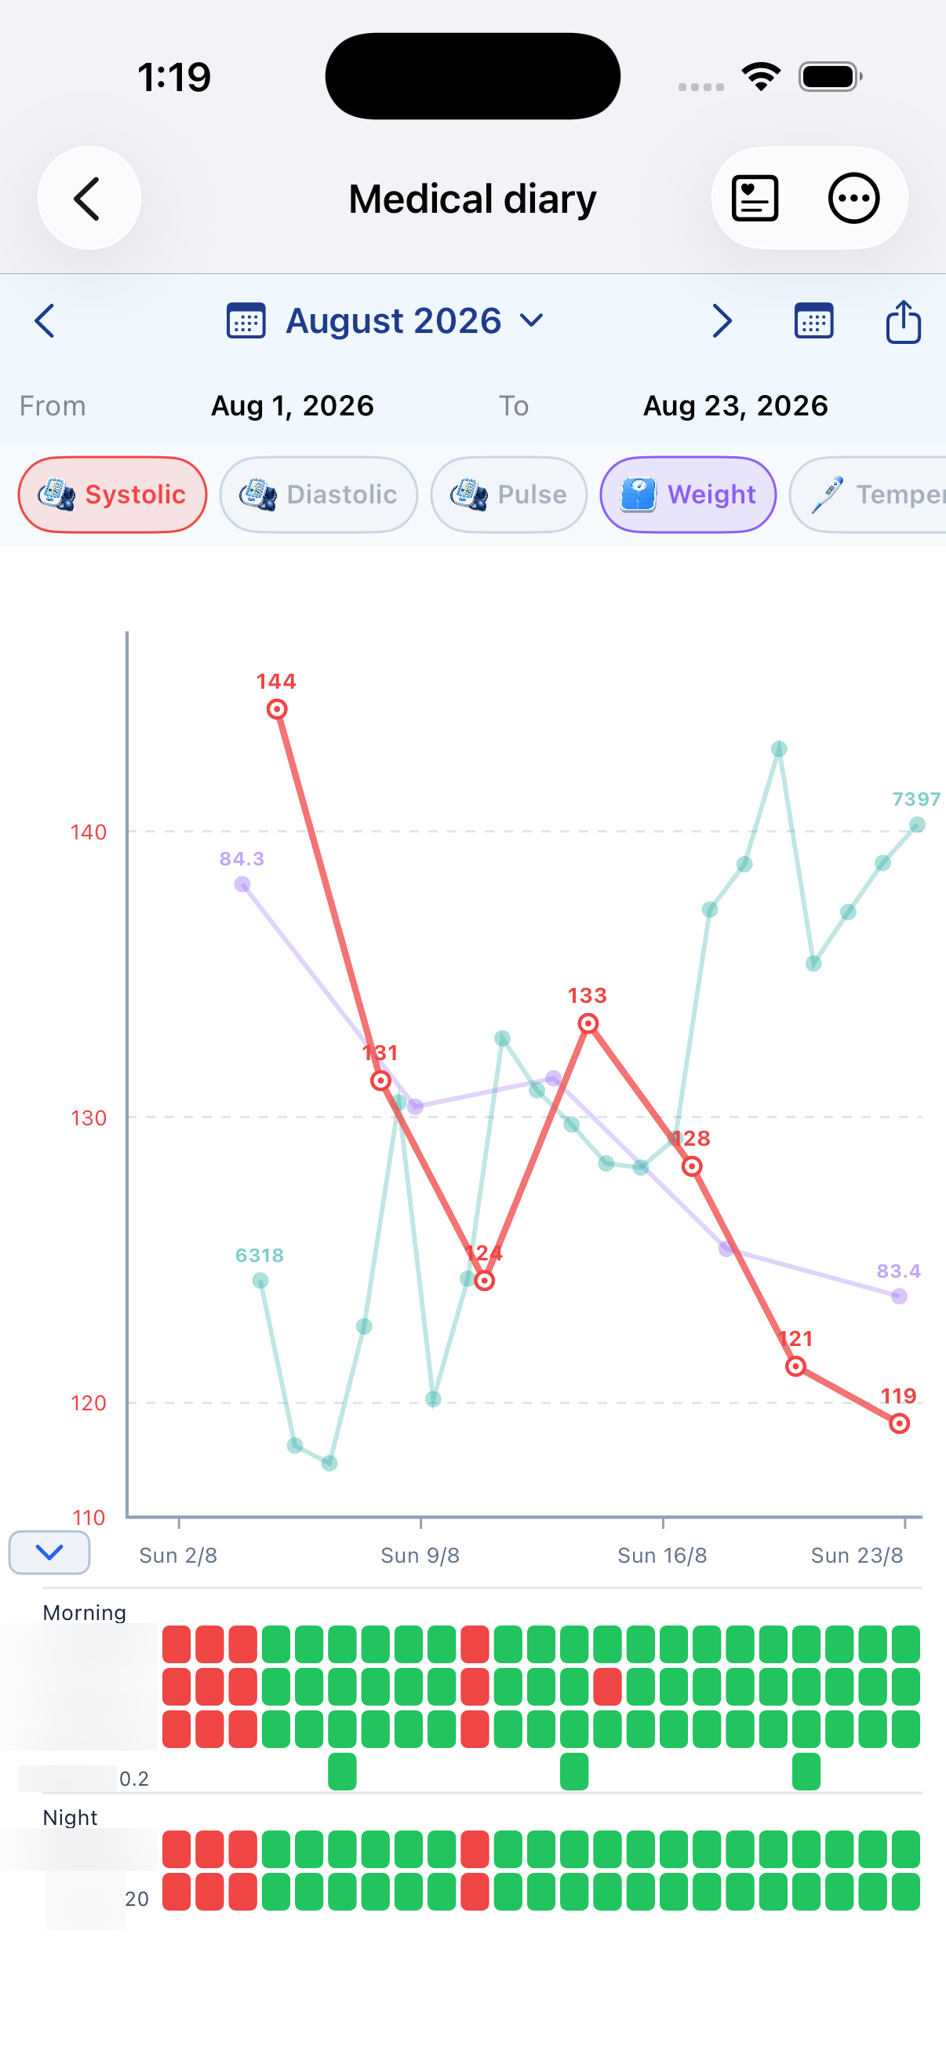
Chart view on Android and iPhone.
Health data: Health Connect and Apple Health records imported into the diary stay on the device and are not sent to Medil servers.

7. Show the diary on a computer
Calendar computer display brings the period you choose onto a larger screen for a visit. The medical calendar, selected-day details, Care plan, measurement charts, and medication timeline stay together as you review the record.
- On the computer, open view.medil.ai.
- In Medil AI on your phone, choose a diary period, then scan the browser QR code or enter its eight-character code.
- Approve the request on your phone. Enter the four-digit verification number shown there into the computer browser.
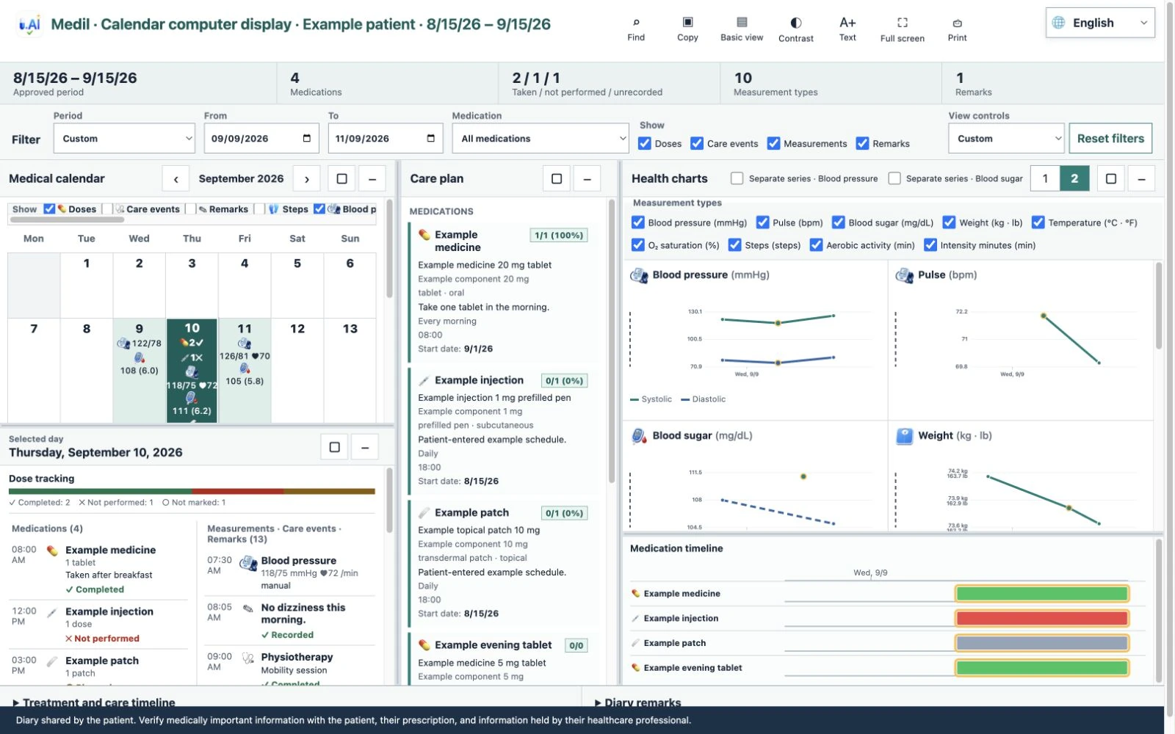
Calendar computer display during a visit.

End-to-end checklist
- Search for each prescribed medication and verify the product, strength, dosage form, and active ingredients.
- Add the prescription and enter the amount, dates, frequency, weekdays, and times exactly as prescribed.
- Turn on Notify me for the required time slots and review the copied notification settings.
- Optionally add a repeating care event and a one-time future task.
- When a reminder arrives, open Care tracker and record each medication and care event.
- Add a remark only when it helps explain what happened.
- Open the medical diary to review the day, then use Calendar computer display or PDF export when sharing history with a health professional.
Final check: Compare the completed Care plan with the written prescription or instructions from your health professional. If anything is unclear, do not infer a dose or schedule from the app.

Quick reference: where to make a change
- Change a prescription or its future schedule: My medications or Care plan.
- Change one recorded dose or care occurrence: Care tracker on that date.
- Change reminder sound or repeats: Notification options in the relevant time slot.
- Review history: medical diary; tap an entry to return to Care tracker for that date.
- Share a record: use diary or chart export after reviewing the selected dates and categories.

When not to continue
Stop and check with a health professional if the product, strength, amount, frequency, protocol, or timing does not match the written prescription. Do not use a reminder or tracker entry as evidence that a dose is medically appropriate.

